Certified Professional in Supply Management
INSTITUTE FOR SUPPLY MANAGEMENT
(CPSM) A supply manager provides leadership by aligning resources to define and satisfy diverse internal and external customer needs through the acquisition and ongoing management of materials and services. CPSM is an upgrade to the renowned C.P.M. program, to expand the horizon and bring the 30 year-old successful certification up to date for today’s global supply chain environment. The training is a world-class program designed to consolidate and strengthen professional competency, and greatly reduce the time required to study and enhance the chance to pass the CPSM exams. CPSM designation is globally the most recognized designation for supply management professionals. The program is designed for experienced supply managers, and focuses on managerial and leadership skills, plus a variety of specialized functions designed to enhance the value of the profession. To compete in today's environment, supply managers must learn to think strategically, broaden their perspective, and view themselves as service providers.

The CPSM Exam is a criterion-referenced occupational certification test, designed to determine whether a candidate is qualified to attain the premier designation of Certified Professional in Supply Management (CPSM) Candidates must pass Modules 1 through 3 of the CPSM Exam, and then apply for their certification.
Training Date
City | Mar | Apr | May | Jun | Jul | Aug | Sep | Oct | Nov | Dec
Shanghai | M1  17-19 | M2  21-23 | M3  19-21 | M1  16-18 | M2  21-23 | M3  18-20 | M1  15-17 | M2  27-29 | M3  24-26
Beijing | M1  17-19 | M2  21-23 | M3  26-28 |  | M1  14-16 | M2  25-27 | M3  15-17 |  | M1  17-19 | M2  15-17
Guang  zhou |  | M1  14-16 | M2  26-28 | M3  16-18 |  | M1  18-20 | M2  22-24 | M3  27-29

Who Should Attend
Supply Chain Directors, Managers, Supervisors and professionals in Purchasing, Project Management, Materials Management, Operations, Supplier Quality Assurance, Finance, Planning, Logistics and other related functions.
Training experts
ISM & CFLP qualified CPSM Trainer

Knowledge system
Module 1  Supply Management Core | Module 2  Supply Management Integration | Module 3  Leadership and Transformation In Supply Management
■ Sourcing  ■ Category Management  ■ Negotiation  ■ Legal and Contractual  ■ Supplier Relationship Management  ■ Cost and Price Management  ■ Financial Analysis | ■ Supply Chain Strategy  ■ Sales and Operations Planning - Demand Planning  ■ Sales and Operations Planning - Forecasting  ■ Sales and Operations Planning - Product and Service Development  ■ Quality Management  ■ Logistics and Materials Management  ■ Project Management | ■ Leadership and Business Acumen - Strategy Development  ■ Leadership and Business Acumen - Stakeholder Engagement  ■ Leadership and Business Acumen - People Development and Coaching  ■ Systems Capability and Technology  ■ Risk and Compliance  ■ Corporate Social Responsibility and Ethics
See the appendix at the end of the paper for detailed course introduction
Copyright Textbooks
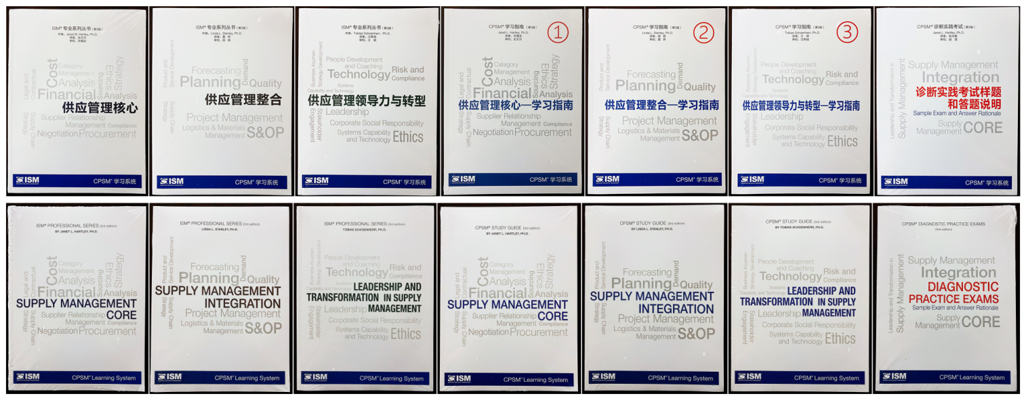
Training Fee
19,380 RMB（ISM member） ( 3 modules/ 9 days）(Language :Chinese)
In which：
Training fee 10,800 RMB,Copyright expenses 2,380RMB,Examination and certification fees5120RMB,Members fee 1,080 RMB,

18,780 RMB（CFLP member） ( 3 modules/ 9 days）(Language :Chinese)
In which：
Training fee 10,800 RMB, Copyright expenses 2,380RMB, Examination and certification fees5,120RMB, Members fee 480 RMB
Contact Us

联系方式：中企联企业培训网
咨询电话：010-62885261 传真：010-62885218
联 系 人：潘宏利 13051501222
电子邮箱：phL568@163.com
网 址：www.zqLpx.com

公开课报名表
公司全称
参加人姓名  Name | 性别  Gender | 职务  Job Title |  | 电话Telephone | 手机  Mobile | 邮 件  E-Mail
付款方式  Payment | 请选择： □ 转账 □ 现金 □ 微信 □ 支付宝
发票提供给 Deliver Invoice to |  |  | □ HR □ 学员
如您有企业内训需求，请与我们联系； 该表可复制

Course Outline: （English）

Module 1 Supply Management Core
Sourcing
■ Assess stakeholder needs and organize into sourcing plans
■ Analyze and advise on feasibility of internal customer requests
■ Analyze potential sources of products or services
■ Determine methods to process requirements for goods or services based on cost, timing, existing contracts and competitive bidding,as appropriate
■ Conduct analyses to develop insourcing or outsourcing strategy
■ Identify and implement technologies to support supply management
■ Leverage spend through the identification, development, and execution of sourcing strategies
■ Implement the strategic sourcing plans aligned with organizational and stakeholder objectives
■ Prepare solicitations for competitive bids, quotations and proposals with pertinent specifications, terms and conditions
■ Evaluate competitive offerings to identify the overall best offer for a product or service
Category Management
■ Create a category management plan to meet the organization's key objectives
■ Execute a category management plan
Negotiation
■ Prepare negotiation plan that aligns with organizational objectives
■ Prepare and develop strategies and tactics for negotiations
■ Lead, conduct and support negotiations with suppliers
Legal and Contractual
■ Manage the preparation of contracts / purchase orders
■ Award contracts to suppliers
■ Administer contracts and/or purchase orders from award to completion or termination
■ Perform or obtain legal review of contracts and other supply management documents
■ Generate and follow supply management processes to ensure legal compliance
Supplier Relationship Management
■ Develop supplier qualification plan to ensure components, materials and suppliers meet specified requirements
■ Develop and manage effective relationships with suppliers
■ Conduct supplier performance evaluations
■ Conduct regular business reviews with suppliers
■ Identify opportunities and benefits for rationalizing the supply base
■ Identify opportunities to drive supplier innovation
■ Develop and implement supplier exit strategies
■ Review supplier performance against negotiated service level agreements(SLAs)
■ Resolve invoice and payment problems
■ Act as a liaison between suppliers and functional areas to ensure accurate information, documentation and product flow
■ Work with suppliers to identify constraints and implement value-added processes
Cost and Price Management
■ Develop cost management program strategies for purchases
■ Perform cost / benefit analyses
■ Conduct spend analysis to determine strategies for a specific categories
■ Track and validate cost savings and cost avoidance
Financial Analysis
■ Prepare and/or administer a supply management department budget
■ Develop financing strategies for purchases
■ Verify that sufficient reporting exists

Supply Management Integration
Supply Chain Strategy
■ Develop and/or implement a material or service standardization program
■ Implement requirements planning to align supply management activities with organizational strategy
■ Implement operations planning, scheduling and inventory control processes to ensure optimum use of resources
■ Structure the supply chain in support of the organization's business strategy
Sales and Operations Planning - Demand Planning
■ Incorporate the use of sales, inventory and capacity forecasts in the planning of materials production to better meet strategic objectives and goals
■ Conduct demand planning
Sales and Operations Planning - Forecasting
■ Analyze and report market conditions, benchmarks and industry trends to internal stakeholders
■ Develop supply forecasts in light of economic and technological trends
■ Plan and communicate sourcing and supply strategies based on forecasted data
■ Manage forecasted data with suppliers
■ Calculate and report forecast accuracy
Sales and Operations Planning - Product and Service Development
■ Participate in new product or service development in support of marketing efforts
■ Participate in product-service ramp-up and/or ramp-down strategies and implementation
■ Create systems and process improvements to help the organization meet sales goals
Quality Management
■ Develop and/or administer a supplier quality certification program
■ Develop measurements for quality improvement
■ Implement continuous improvement processes within the supply chain
Logistics and Materials Management
■ Design transportation and distribution policies and procedures to ensure optimum flow of materials
■ Manage transportation, invoicing and documentation functions to ensure regulatory compliance
■ Manage the resolution of delivery / receiving problems
■ Analyze supplier transportation costs
■ Develop and/or implement a warehouse management system
■ Conduct network design and optimization to support the business model, increase productivity and lower operating costs
■ Oversee the day-to-day operations of a warehousing function
■ Develop and/or implement an inventory management system
■ Coordinate and/or monitor the movement of equipment and assets within the organization
■ Expedite/de-expedite orders
■ Develop and/or execute plans and metrics to reduce risk of shortages
■ Identify cost-effective packaging that meets requirements
■ Conduct investment recovery activities for surplus / obsolete materials
Project Management
■ Perform project management activities

Leadership and Transformation In Supply Management
Leadership and Business Acumen - Strategy Development
■ Participate in organization-wide objective goal setting
■ Participate in organization-wide budgeting
■ Develop, implement, revise and support business plans and operating policies and procedures
■ Participate in company mergers, acquisitions and/or divestitures
Leadership and Business Acumen - Stakeholder Engagement
■ Develop and evaluate supply management relationships with internal departments
■ Lead or participate in cross-functional and/or multifunctional teams
■ Disseminate information and promote training related to supply management policies and procedures
■ Market the value of strategic sourcing and sourcing strategies and initiatives to management and internal stakeholders
■ Represent supply management in meetings with corporations, government agencies, professional associations and/or other organizations
Leadership and Business Acumen - People Development and Coaching
■ Evaluate the supply management organizational structure and modify as necessary in order to achieve ■ the optimal structure
■ Conduct role design evaluation and potential job redesign requirements

■ Develop criteria for evaluating the overall supply management department performance
■ Hire,develop, retain, promote and/or dismiss supply management personnel
■ Conduct and/or authorize job training for the professional development of the staff
■ Evaluate supply management employee performance
■ Supervise and lead supply management employees
■ Create and manage a succession plan
Systems Capability and Technology
■ Incorporate the use of technology-driven processes to analyze data and make more informed business decisions
■ Conduct ongoing research of the market, current competition, company imperatives, recent trends and ■ emerging capabilities that will provide competitive advantage
Risk and Compliance
■ Implement a risk management program
■ Develop risk mitigation plans that align with organizational risk tolerance
■ Implement a claims management program
■ Implement and maintain a system of data retention
■ Manage the storage and disposal of hazardous and/or regulated materials
■ Develop tools and processes to measure, report and improve compliance with supply management policies and regulations
■ Analyze and resolve issues in supply management audit reports
■ Assess, manage and monitor the risk of doing business with third parties and their subcontractors
■ Investigate and/or verify fraudulent or non-compliant employee purchases
Corporate Social Responsibility and Ethics
■ Develop and implement a code of business conduct for the supply management function
■ Develop and/or implement a supplier diversity program
■ Establish and monitor programs for sustainability and environmental responsibility
■ Implement, monitor, and promote organizational and supply chain health and safety policies and procedures
■ Establish and monitor social responsibility programs including corporate citizenship and community outreach
■ Implement policies to prevent discrimination and harassment

